**ServiceNow User Interface Overview**

The ServiceNow user interface has two components: -

* Banner
* Content frame

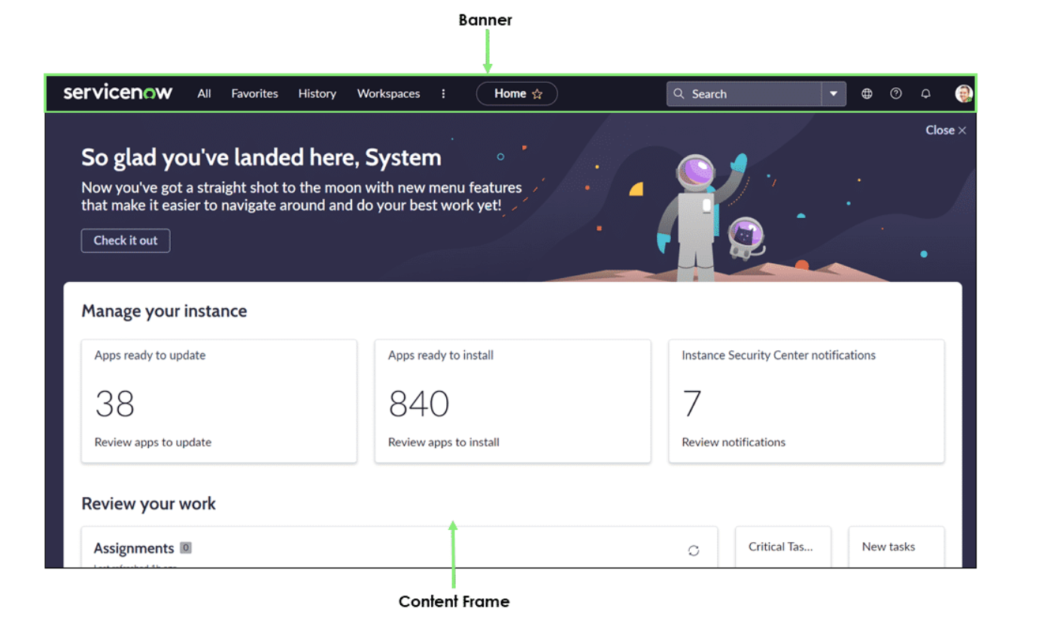

The banner spans the top of every page. It contains a logo, navigation menus, the title of the page in the content frame, global search, help, notifications, and a user menu.

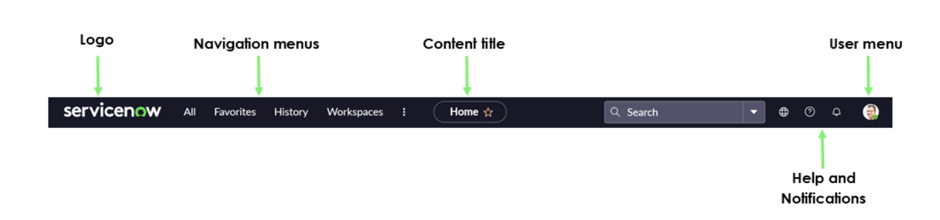

Global Search: Global Search is used to search results that includes all the items the search term appears in. By default, global search results can include: -

* Cases
* Customers or Users
* ServiceNow Community Questions
* Incidents
* Change Requests
* Problems
* Knowledge Articles

To enter search terms, we need to click in the search icon and enter the search term in the search field.



Connect Chat: Connect chat is a real-time messaging tool that enables users to chat with individuals and groups, quickly share files and collaborate on any record by connecting with right people instantly. (IMPORTANT: Connect Chat is not available in Next Experience. Starting with Washington DC, certain Connect Chat functions are available in Next Experience by using Sidebar.) Connect Chat animates communication around records, Visual Task Boards, topics of interest, or groups of people. Features include:

* Direct conversations between two users.
* Group conversations between three or more users.
* Conversations linked to records. Comments and work notes appear in conversations in real time and users can update the record directly from the conversation.
* Drag-and-drop sharing of links, files, and records.

Contextual Help: The ServiceNow system provides several preconfigured help contexts that are connected to a link that display the exact information needed for the current list, form, or record. Help topics can be defined by own which then configures all to appear when the help icon is clicked in a ServiceNow record. Users click the help icon to open the default help pages provided in the base system. For any page that does not have context-sensitive help defined, the instance displays the help system welcome page. Users can use the search feature or the index to find the correct help topic. The location of the help icon depends on the user interface version.

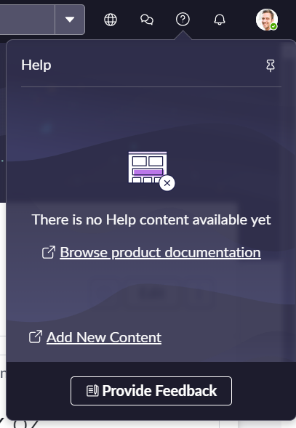

Application Navigator: